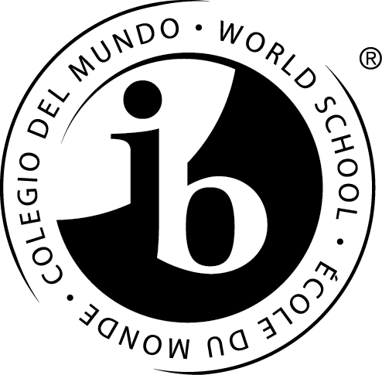

|  |  |  |
| --- | --- | --- |
|  | Po Leung Kuk Ngan Po Ling College  保良局顏寶鈴書院  26 Sung On Street, Tokwawan, Kowloon  九龍土瓜灣崇安街26號  Tel 電話： 2462 3932 Fax 傳真： 2462 3929 |  |

|  |  |  |
| --- | --- | --- |
|  | **International Baccalaureate (IB) Diploma Programme**  **Bridging Year Programme Application Form**  **2025 – 2026 (For Internal Students Only)** | **Application No.** |
|  |
| **Date Received** |
|  |

|  |  |  |  |  |  |  |  |  |  |  |  |  |  |
| --- | --- | --- | --- | --- | --- | --- | --- | --- | --- | --- | --- | --- | --- |
| Name of Student | | (Surname) (Given name) | | | | | 學生姓名 | | | (姓) (名) | | | |
| Sex | | Age | | Nationality | | | | | Ethnicity | | | | |
| Spoken Language at Home | | | | First Language | | | | | Second Language | | | | |
| Date of Birth  (dd-mm-yy) |  | | | | | | | | | | | Please affix  recent photo | |
| HKID Card No. |  | | | | | | | | | | |
| Correspondence  Address | Flat | | Floor | Block/Building | | | | | | | |
| Estate/Village | | | | | | | | | | |
| Street | | | | District | | | | | | |
| Telephone No. | Home | | | | | Mobile | | | | | | | |
| E-mail |  | | | | | | | | | | | | |
| Previous  School(s) | Name of the School | | | | | Class | | Conduct | | | Position in Form | | School Year |
|  | | | | |  | |  | | |  | | – |
|  | | | | |  | |  | | |  | | – |
|  | | | | |  | |  | | |  | | – |
| Extra-Curricular Activities | Year | | | Descriptions | | | | | | | | | |
|  | | |  | | | | | | | | | |
|  | | |  | | | | | | | | | |
|  | | |  | | | | | | | | | |
| Awards obtained |  | | |  | | | | | | | | | |
|  | | |  | | | | | | | | | |
|  | | |  | | | | | | | | | |

|  |  |  |  |
| --- | --- | --- | --- |
|  | Father | Mother | Guardian |
| Name in Full |  |  |  |
| Occupation & Position |  |  |  |
| Name of Company |  |  |  |
| Education Level |  |  |  |
| Contact No. |  |  |  |

**Choice of subjects:**

Please indicate your preference over the subject stream choice and please mark ‘1-4’ with 1 as the most preferred choice.

|  |  |  |  |  |
| --- | --- | --- | --- | --- |
| **Science** | |  | **Arts** | |
| English | |  | English | |
| Chinese / French**\*** | |  | Chinese / French**\*** | |
| Economics / Geography**\*** | |  | Visual Arts | |
| Chemistry | |  | Economics / Geography**\*** | |
| Biology / Physics**\*** | |  | Biology / Physics**\*** | |
| Mathematics | |  | Mathematics | |
|  |  |  |  |  |
| **Engineering** | |  | **Business / Social Science** | |
| English | |  | English | |
| Chinese / French**\*** | |  | Chinese / French**\*** | |
| Economics / Geography**\*** | |  | Economics | |
| Chemistry / Geography**\*** | |  | Geography | |
| Physics | |  | Biology / Physics**\*** | |
| Mathematics | |  | Mathematics | |

**\*Please delete the inappropriate for the subject options.**

**Note:**

* Depending on the number of enrolment for each combination, all subject combinations will be subject to change.
* French is only available for non-Chinese students.
* A subject will be offered only if there are at least 5 students opting for it.

I declare that to the best of my knowledge and believe the information listed in this form is true and correct.

If false information is provided, the application will be rendered null and void.

|  |  |  |  |  |  |
| --- | --- | --- | --- | --- | --- |
| Name of Parent/ guardian | : |  | Signature of Parent/ guardian | : |  |
|  |  |  | Date | : |  |

**Remarks on Application Form Submission**

**Students of Po Leung Kuk Ngan Po Ling College** should submit the completed application form **THROUGH ECLASS EMAIL** to [ib@home.npl.edu.hk](mailto:ib@home.npl.edu.hk).

**Remarks on Application of School Fee Remission**

Details for the school fee remission can be obtained from:

<https://www.npl.edu.hk/uploads/files/1%202024-2025%20Fee_Remission_and_Scholarship_Schemes%20%28Website%29.pdf>

Newly admitted students could apply for the school fee remission within 4 weeks after the commencement of the new school year.

The completed application form, together with all required documents, must be submitted IN PERSON to Po Leung Kuk Ngan Po Ling College.

(Application made by post or fax will NOT be entertained) For school fee remission enquiries, please contact us at 2462 3932.

**For further details about the IB Diploma Programme you can write to:**

IBDP Coordinator: Ms. Iu Yiu at [yiu@home.npl.edu.hk](mailto:yiu@home.npl.edu.hk).